INTERATION EXPERIENCE

**Part 1: 5 interations that I experience daily.**

1. Doulingo App:

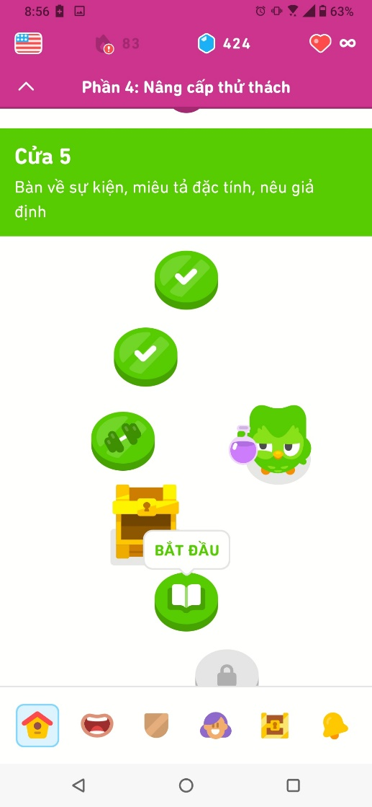

Doulingo is a famous language learning app in the world and I use it to learn english everyday in my spare time or before I go to bed. With my english learning demand, I download a lot of app to studying english but Doulingo is the only app which has kept me the longest. Doulingo have an eye-catching design with the green color and a green owl like a representative charater.

I always use it on my phone because it is convenient to use every where, every time.

When interacting with doulingo, I usually try to overcome lessons, join in the big tournament and friend tasks every week, practise pronounciation and get new streaks to represent my effort daily.

Doulingo is very attractive and stimulate my interest in english with colorful design and exciting lessons. If I forget to practise, the app will remind me with some provocative and encourage words. When studying english on Doulingo, I have experienced feeling from excited, worried, nervous, disapointed and happy when I gain new knowledge and win the tournament.

1. Fan:



I am sure that I cannot overcome summer when I don’t have the fan, because my room is located in the direction that the sun shines almost all day, so it is so hot but my landlord want to save electric so he usually turns of the air condition. Therefore, the only way to relieve the heat is to use a fan.

My fan has a simple and compact design with white and I can easily use it in the first time. I have plugged the fan’s power cord into an electrical outlet for it to work. I use the buttons at the base of the fan to increase or decrease the speed and a button that can be pushed or pulled to adjust the direction of the fan's rotation. Except when I am at school, I turn on my fan all day.

Sometimes, I feel a bit annoyed when the fan doesn't rotate in the right direction I want when it's scorching outside, making me to have to go back and forth to adjust it. Besides that, I'm quite satisfied that it helps me relieve the heat.

1. The water bottle:

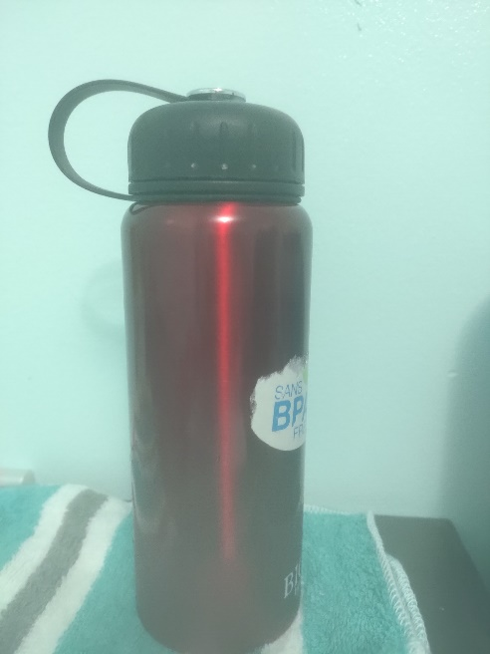

The water bottle is an indispensable part of my daily life because I have to go down stair to get water every time it runs out and I am quite lazy. My bottle has a capacity of 1 liter, so it can help me to decrease the time that I go down stair.

The water bottle has a compact design with a red body and a black screw cap cannected by a plastic strap to avoid losing the cap.

When using it, I only need to twist the cap to open and drink water, it is so easy.

It is very convenient because I can take it to every where, expecially when I have to go to a far distance that I cannot buy water. I feel satisfied when I carry it with me. I like my bottle because it is friendly with environment that I can use it many time until it might be broke.

1. Electronic Stove:



I use electronic stove about 3 times per day for cooking my breakfast, my luch and my dinner. Actually, I love cooking and eating new food every meals, Therefore, interacting with an lectronic stove is not weird.

The electronic stove in my house is have many functions, it can use to warm up, cook food and it has a built-in oven underneath. It also have 5 places to cook, therefore I can cook 4 foods and warm up a food in one time. There are 5 knobs to adjust the cooking teamperature with a control panel to set up temperature, time, other functions for the oven. I press and turn the knob when I want to cook and adjust the temperature, after I put my pan or pot on the stove.

I feel it is useful and multifuntional, therefore it help me to save time to cook and enjoy vietnamese food when I cook it for myself. Although cooking is hard and make me feel tired, but I am happy to use this stove because of its convenience.

1. The Desk Lamp:

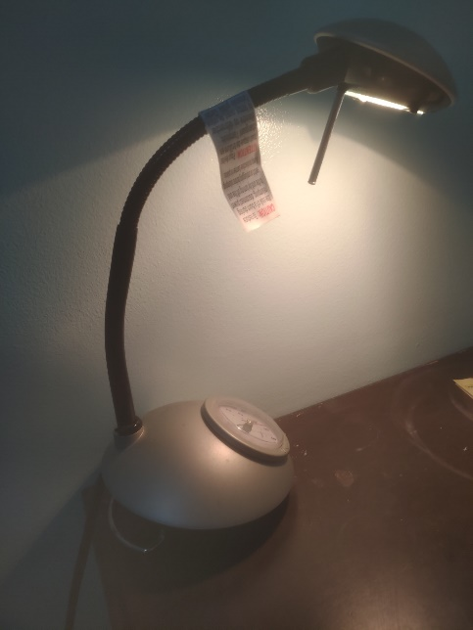

I always use my desk lamp for my studying in the evening, because it is not enough light in the evening to study.

My lamp has a simple design with grey and black, it also have a clock on the base of lamp to watch. There is a metal rod on the top of the lamp to prevent the bulb from being hit when it falls. The spring-loaded black connecting rod allows me to adjust it easily. The power cord has a built-in switch to turn it on or off when needed. Therefore, I only turn the switch and adjust the head of lamp in the direction I want and use it.

I feel it quite easy to use. The lamp has the yellow light that help relieve and protect my eyes, therefore I am really satisfied and love this device so much.

to reach a new streak and get more knowledge as I play a game to get experience. Every week, I join in a big tournament in which I have to match vocabularies with their meaning as fastly as possible to reach more diamond and go to higher level of the tournament.

After I get a new aim, Doulingo will give me some awards such as diamonds to buy something in their store, or doubling experience.

**Part 2: In-Depth Analysis:**

After writing about 5 interactions that I have daily, i want analyze Doulingo deeply because it bring to me a lot of great experience.

As I said, Doulingo help me to learn English actively. I can study all skills in English such as listening, speaking, reading and writing including vocabulary and grammar, pronunciation and so on. In addition, Doulingo is a language learning app, therefore I can study other languages. But I focus on English right now. Doulingo give me daily purposes that I have to complete a lesson at least to level up and get a new streak to extend my studying days. It can be a month, a year or many years and that is a pride. Moreover, I can join in the weekly tournament that I can compete with many people in the world to get the high rank to have more diamonds and participate in a higher battle.



Doulingo with a iconic image of a green owl, it attracted me at the first sight.

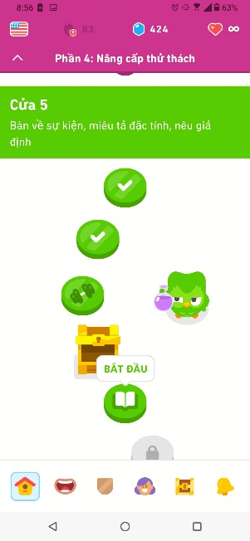

When I go into the app, I can see the user-friendly interface. The design is simple, easy to use but colorful, making users excited to use it. The cartoon images and facial expressions of the characters are very eye-catching . I can see the flag of language that I am studying, the number of days I have studied English, the number of diamonds and times I can study in the header. Next, the name of challenge and lessons that I have to overcome. In the footer, there are some icons of other windowns such as home, pronunciation lesson, the tournament, friends challenges, prizes and notification. It is quite easy to interact with this app.

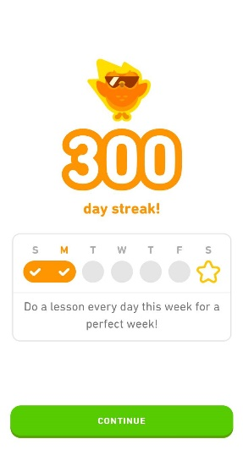

By the way marking streaks of users, Doulingo stimulates them to learn everyday to keep their streaks, and Doulingo will use compliments to encourage the users when they get new achievement in the streaks. Although I am not a deligent student, I always use about 15 minutes to complete my lessons to extend my streaks.

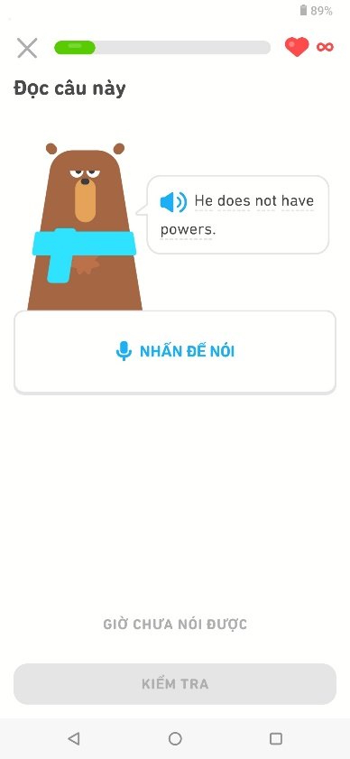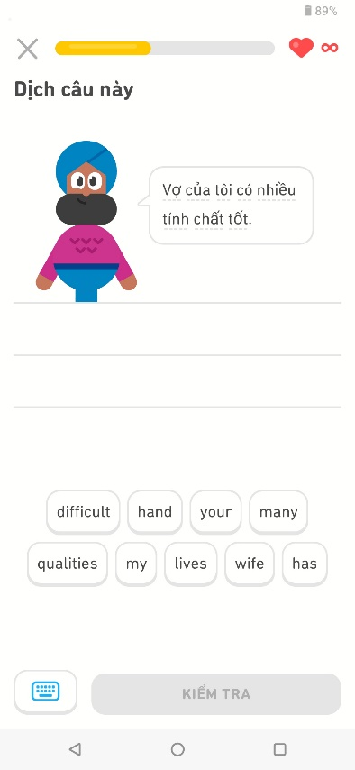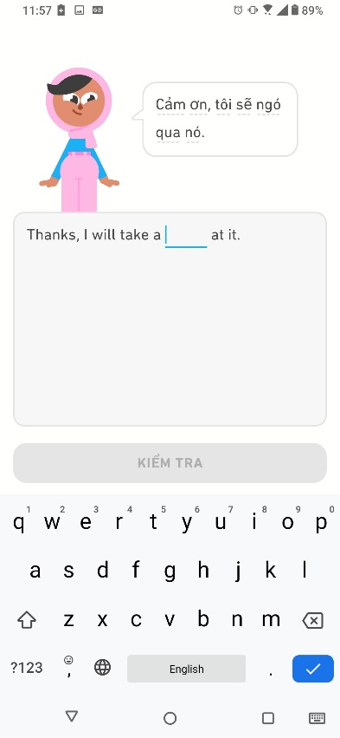

The exercises are very diverse, from speaking practice, listening practice, filling in words and translating sentences. The user do not feel bored when they study on Doulingo with vivid images and sounds of native speakers. The exercises will be repeated many times to help users to remember vocabulary, grammar and how to pronounce. I think it is very useful. After every lesson, the user have to answers the difficult question in the end of the lesson to level up and go to a new lesson. If they are wrong in 3 questions, they will have to do the test again.

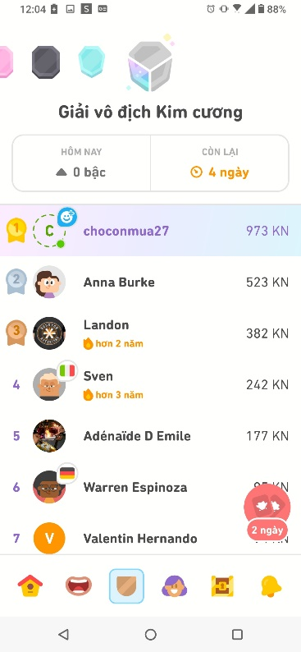

Last but not least, the important part of Doulingo that keep me studying in this app is the weekly tournament where I can have matches with many people in the world to get the first rank. This is a tough match, because with just a little bit of negligence, someone else will take your position. The weekly tournament stimulated my excitement, so there were nights when I stayed up until 3am to fight for the top spot.

With activities on Doulingo, the user will use their keyboard on the phone to fill in the blanks, or choose tags including words to fill in a sentence. Moreover, they use micro on the phone to speak in the speaking exercises. In the tournament, almost matches is matching the words with their meanings, therefore, It requires the user's quick eyes and operations, as well as a good memory.

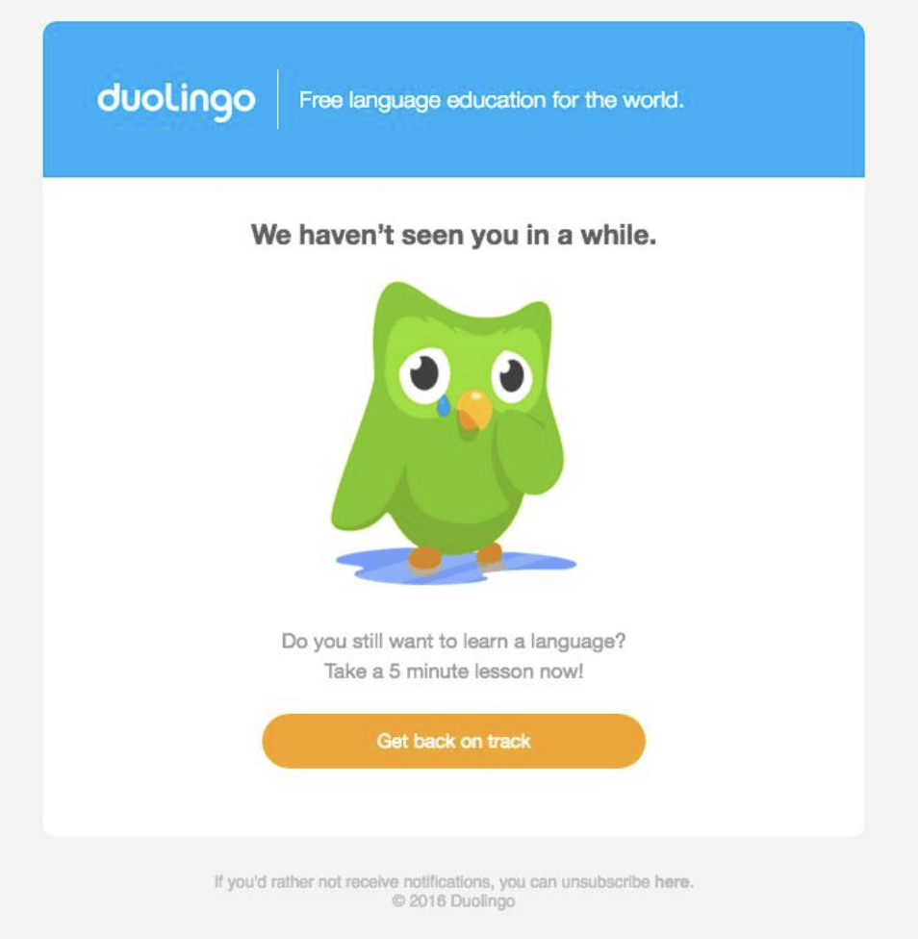

Doulingo has an interesting part that everybody also know, that is notifications to remind the users to study when they forget or they are lazy. The owl will send notification emails with provocative and sarcastic opening statements to users and this is the special feature of this language learning app like the saying "so you chose to be a failure". It is so funny, but stimulating our inside excitement.